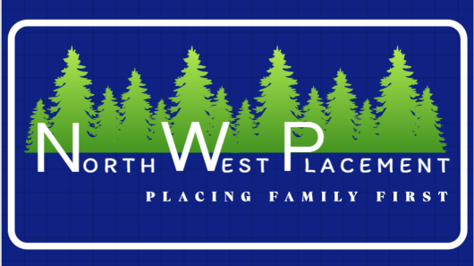
Authorization to Obtain and Release
Confidential HealthCare Information

Name of person(s) seeking senior living options: __________________________________

Name of the referral agency to obtain and release information:
North West Placement LLC
5225 Norman Rd
Stanwood, WA 98292

North West Placement LLC will use this information for the sole purpose of locating senior living options. Information obtained and released may include the following information:

A comprehensive overview of recent medical history, prescribed medications, and ongoing medication management requirements, along with medical diagnoses, health concerns, and reasons for seeking care. It also includes significant behaviors or symptoms that necessitate special attention, required assistance with daily living activities, cultural and language accessibility needs, activity preferences, sleeping patterns, financial basics, current living situation, geographic location preferences, and other personal priorities, such as dietary choices and daily routines.

I authorize North West Placement to obtain and release healthcare info from the following:

□In-Home Care Agencies □Assisted Living Facilities □Adult Family Homes □Hospitals □Skilled Nursing Facilities □Physicians’ Offices □Other: ___________________

Authorizing signature: ___________________________________Date: ___________

Printed name of signer: ___________________________________
Relationship of signer to person seeking options: □Self □Spouse □Healthcare DPOA □Financial DPOA □Other: _______________________________________________

*This authorization will expire one hundred and eighty (180) days after this document is signed.

